FIFO code

library IEEE;
use IEEE.STD_LOGIC_1164.ALL;
use IEEE.NUMERIC_STD.ALL;

entity fifo1 is
Port (
clk : in STD_LOGIC;
reset : in STD_LOGIC;
WriteEn : in STD_LOGIC;
DataIn : in STD_LOGIC_VECTOR(1 downto 0);
ReadEn : in STD_LOGIC;
DataOut : out STD_LOGIC_VECTOR(1 downto 0);
Empty : out STD_LOGIC;
Full : out STD_LOGIC
);
end fifo1;

architecture Behavioral of fifo1 is

constant FIFO_DEPTH : natural := 4;

type FIFO_Memory is array (0 to FIFO_DEPTH-1)
of STD_LOGIC_VECTOR(1 downto 0);

signal Memory : FIFO_Memory :=
(others => (others => '0'));

signal Head : natural range 0 to FIFO_DEPTH-1 := 0;
signal Tail : natural range 0 to FIFO_DEPTH-1 := 0;
signal Count : natural range 0 to FIFO_DEPTH := 0;

signal dataOutReg : STD_LOGIC_VECTOR(1 downto 0)
:= "00";

begin

DataOut <= dataOutReg;
Empty <= '1' when Count = 0 else '0';
Full <= '1' when Count = FIFO_DEPTH else '0';

fifo_proc : process(clk, reset)
begin
if reset = '1' then
Head <= 0;
Tail <= 0;
Count <= 0;
dataOutReg <= "00";

elsif rising_edge(clk) then

if WriteEn = '1' and ReadEn = '0'
and Count < FIFO_DEPTH then

Memory(Tail) <= DataIn;

if Tail = FIFO_DEPTH-1 then
Tail <= 0;
else
Tail <= Tail + 1;
end if;

Count <= Count + 1;

elsif ReadEn = '1' and WriteEn = '0'
and Count > 0 then

dataOutReg <= Memory(Head);

if Head = FIFO_DEPTH-1 then
Head <= 0;
else
Head <= Head + 1;
end if;

Count <= Count - 1;

end if;

end if;
end process;

end Behavioral;

RTL Design:

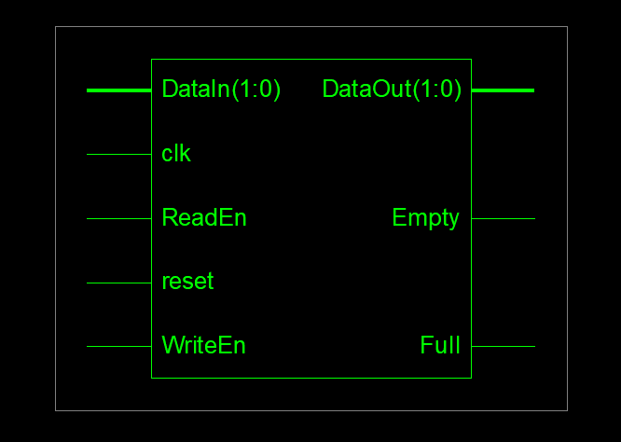

Output:
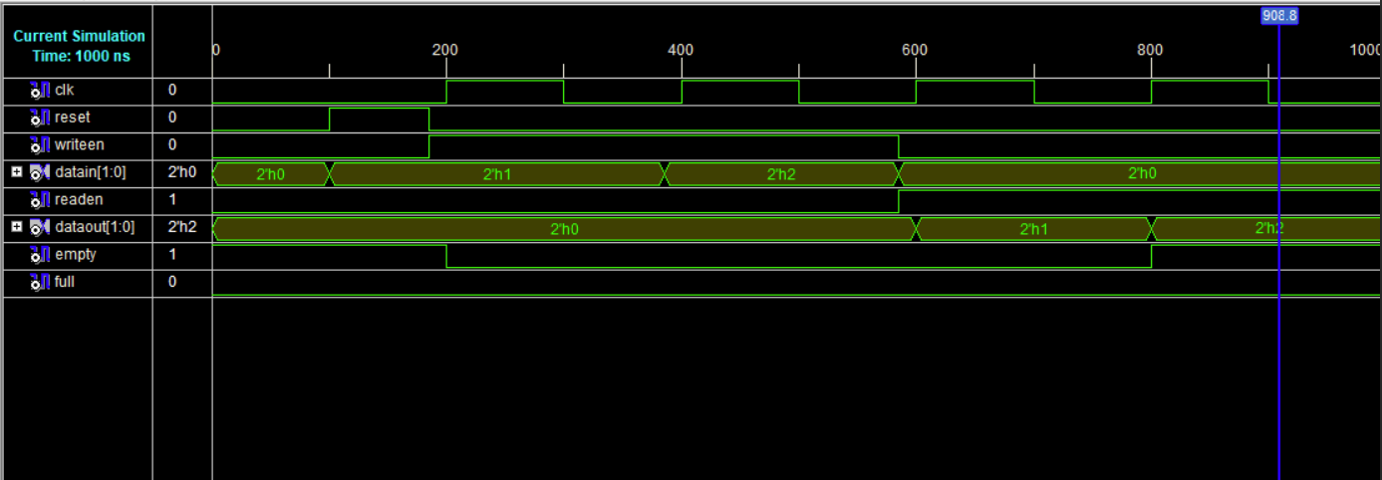

Pin Assignment:
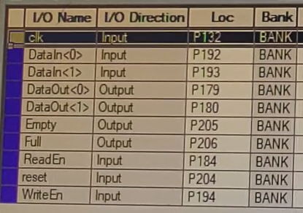

Output:
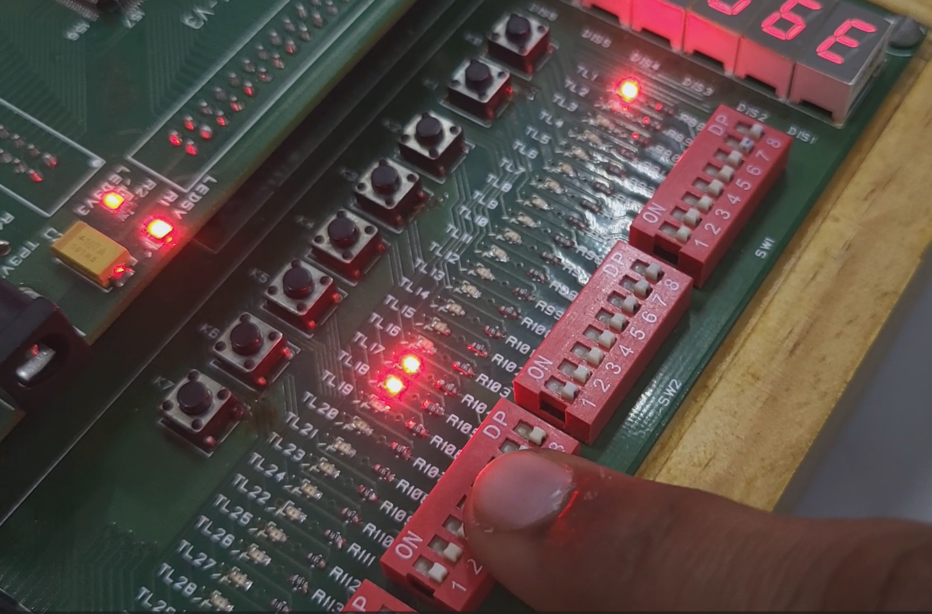

Total memory usage is 208024 kilobytes

Number of errors : 0 ( 0 filtered)
Number of warnings : 0 ( 0 filtered)
Number of infos : 1 ( 0 filtered)

